DiamondMind 3D Printer

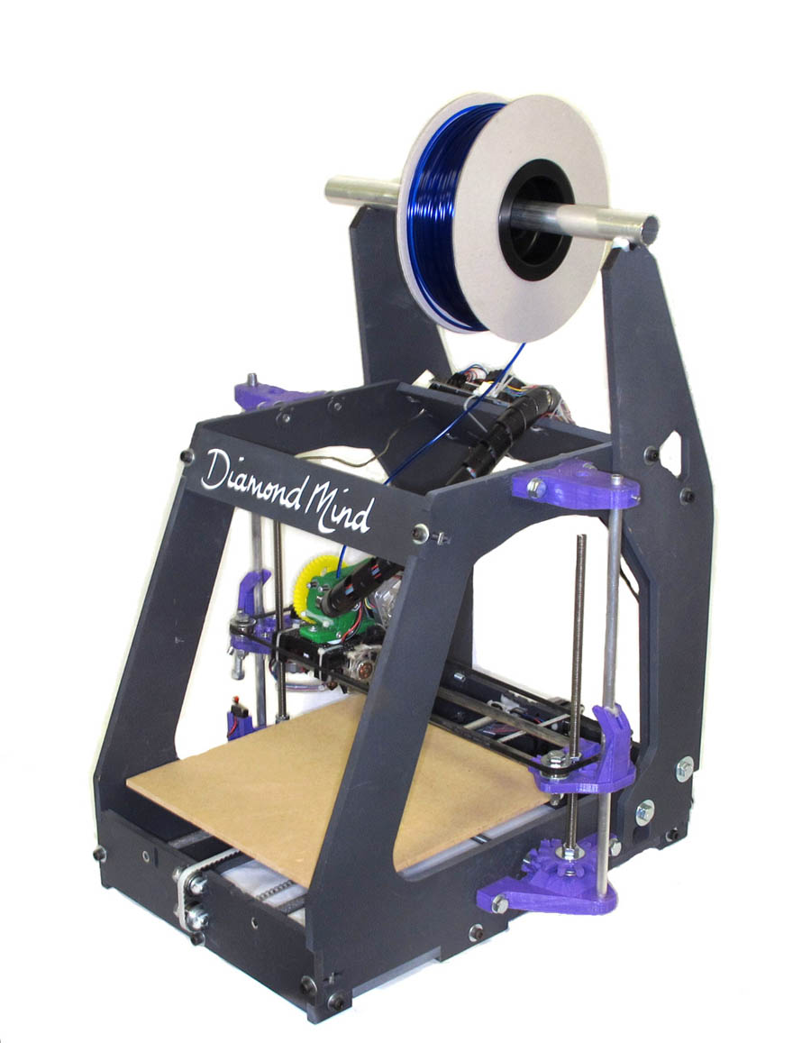

Documentation – printed parts

These are the printed parts supplied.
This allows you to identify the parts by name
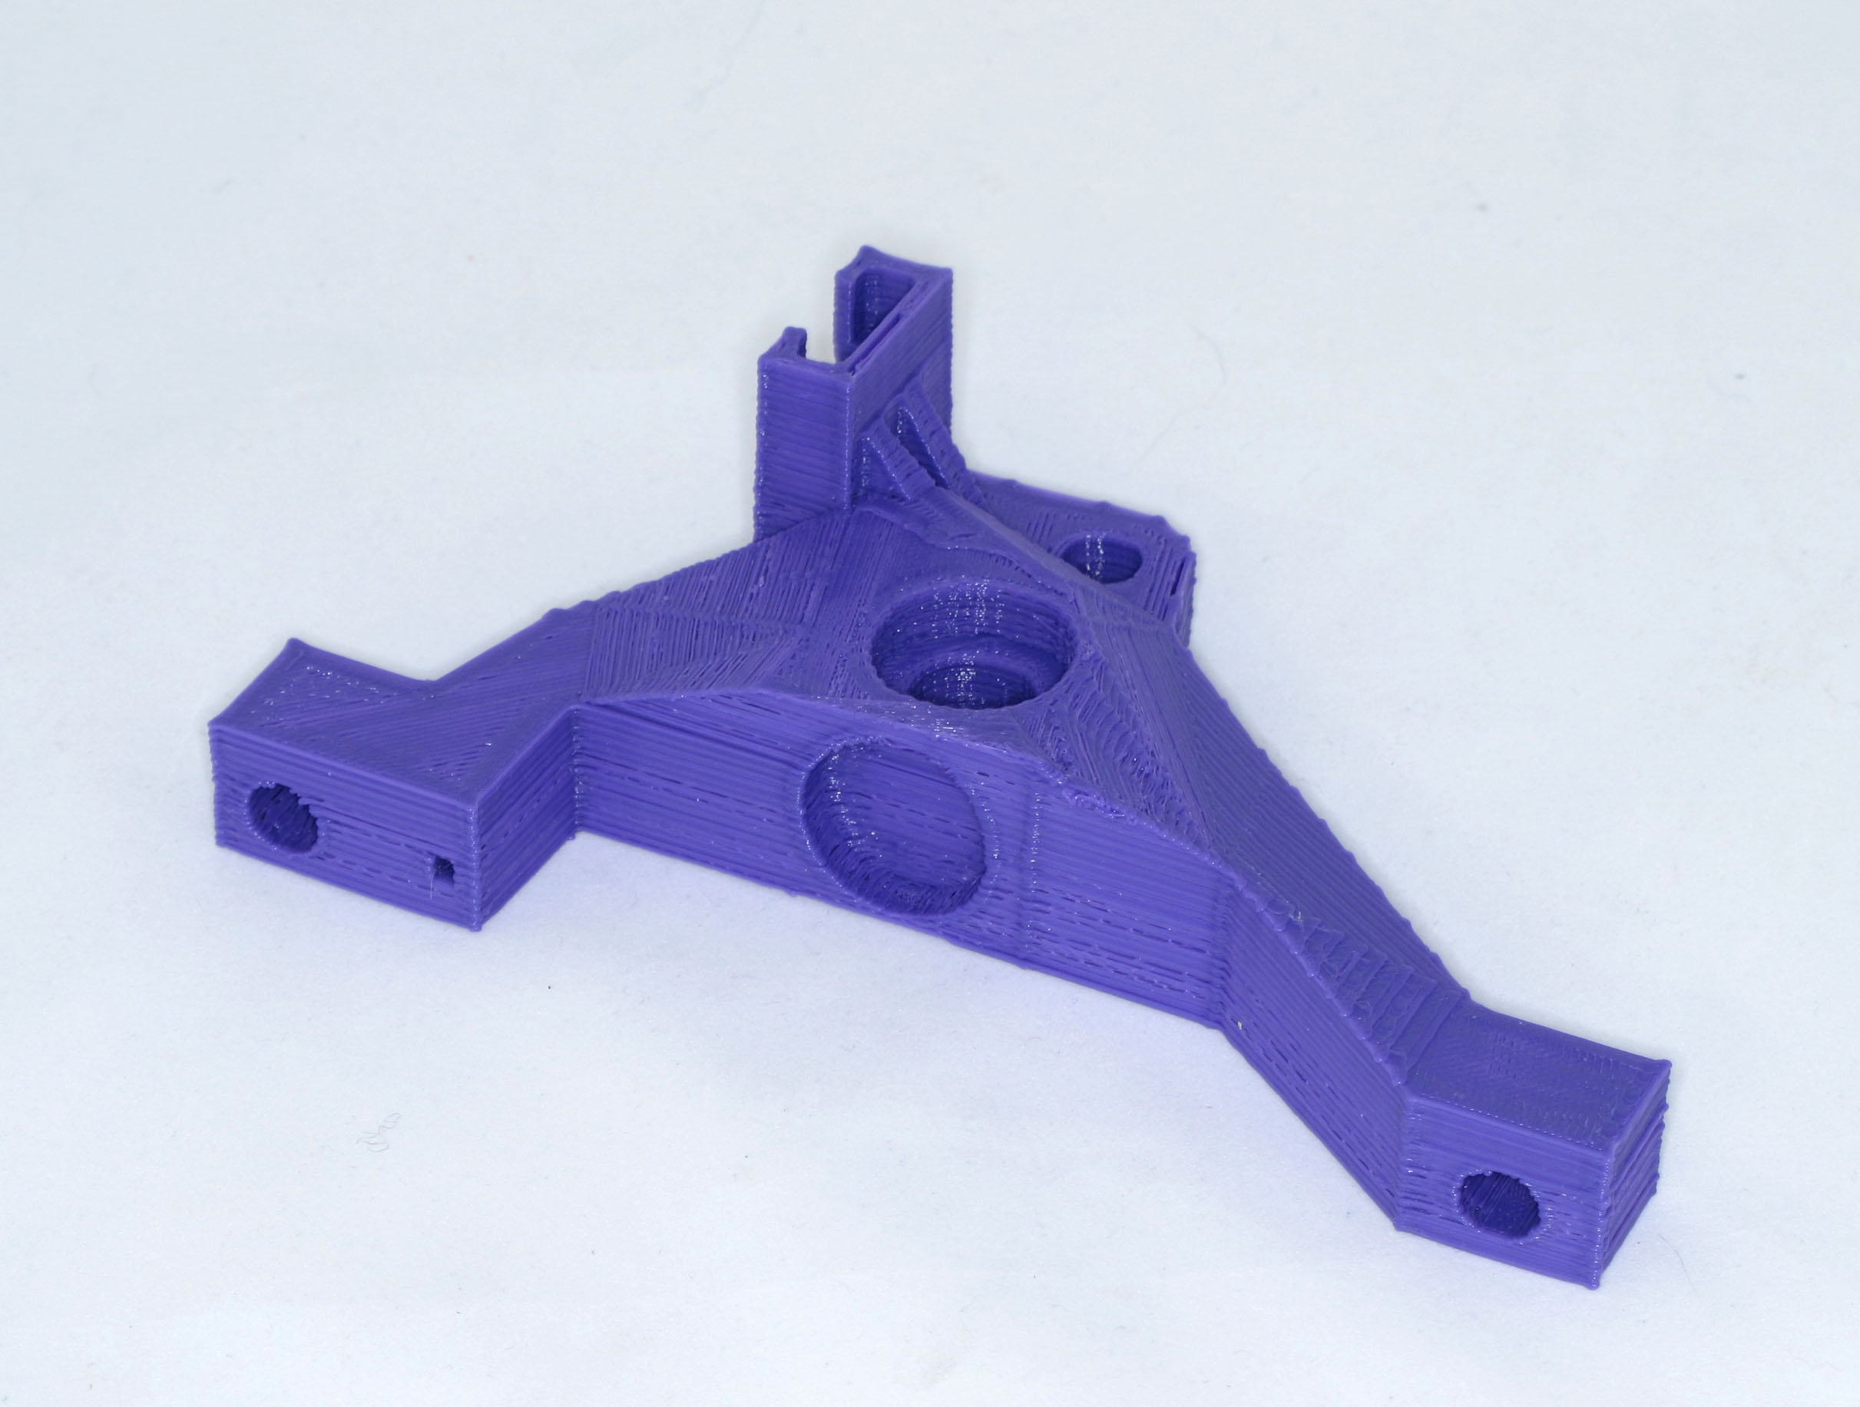Illustration 2: Z Motor Side Bracket
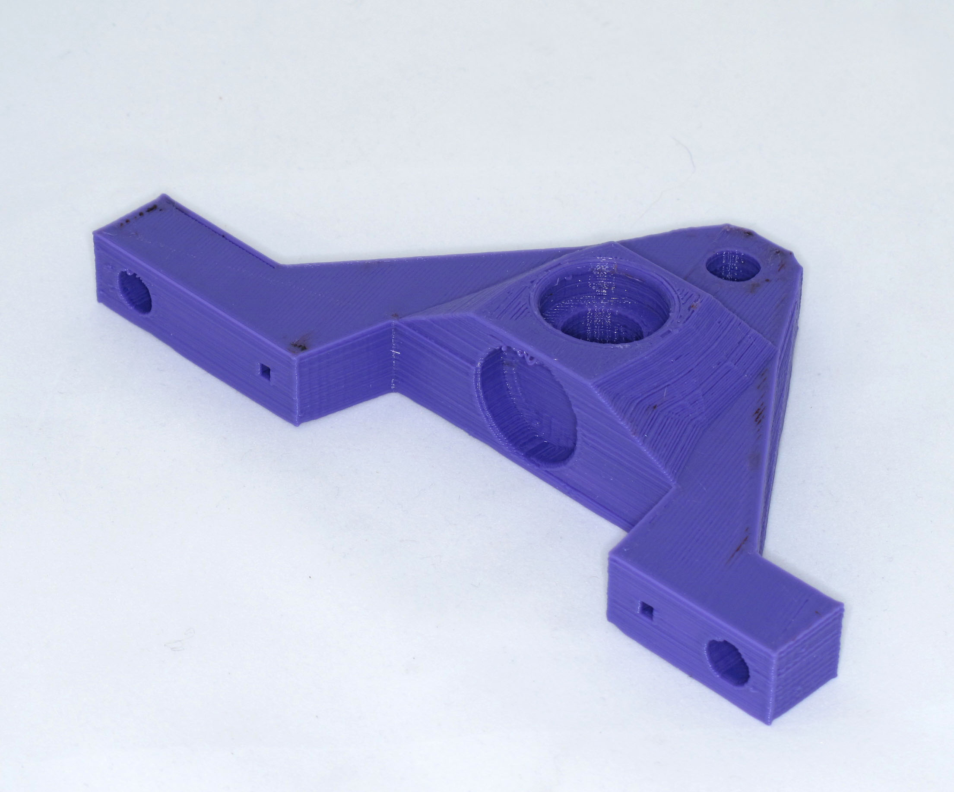Illustration 1: Z idler Bracket
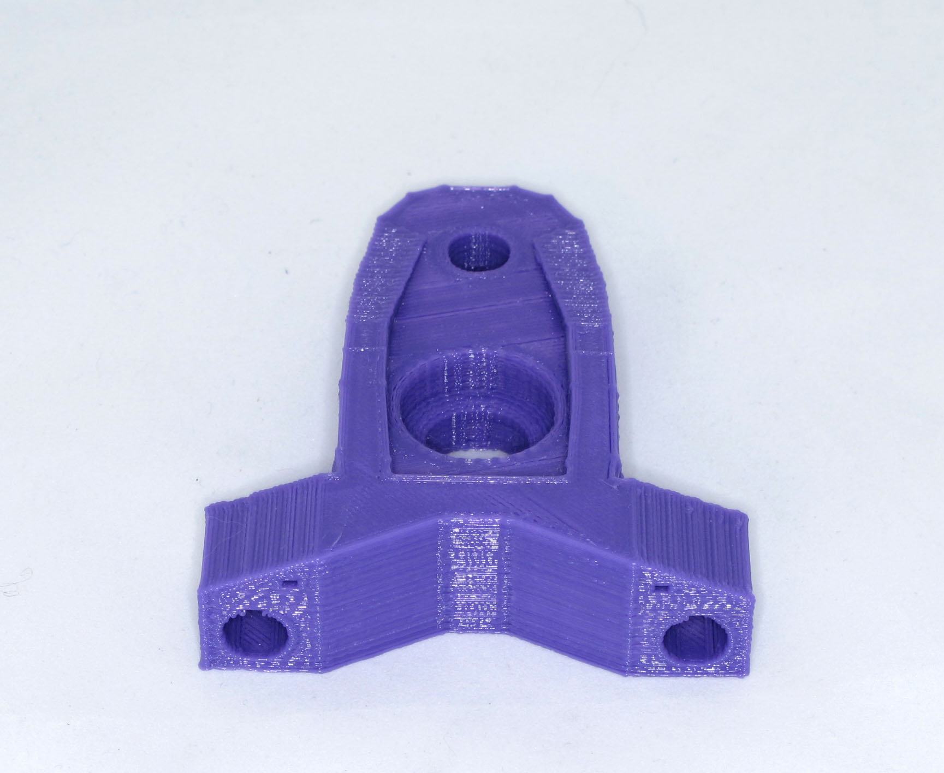Illustration 3: Z Top Brackets x2
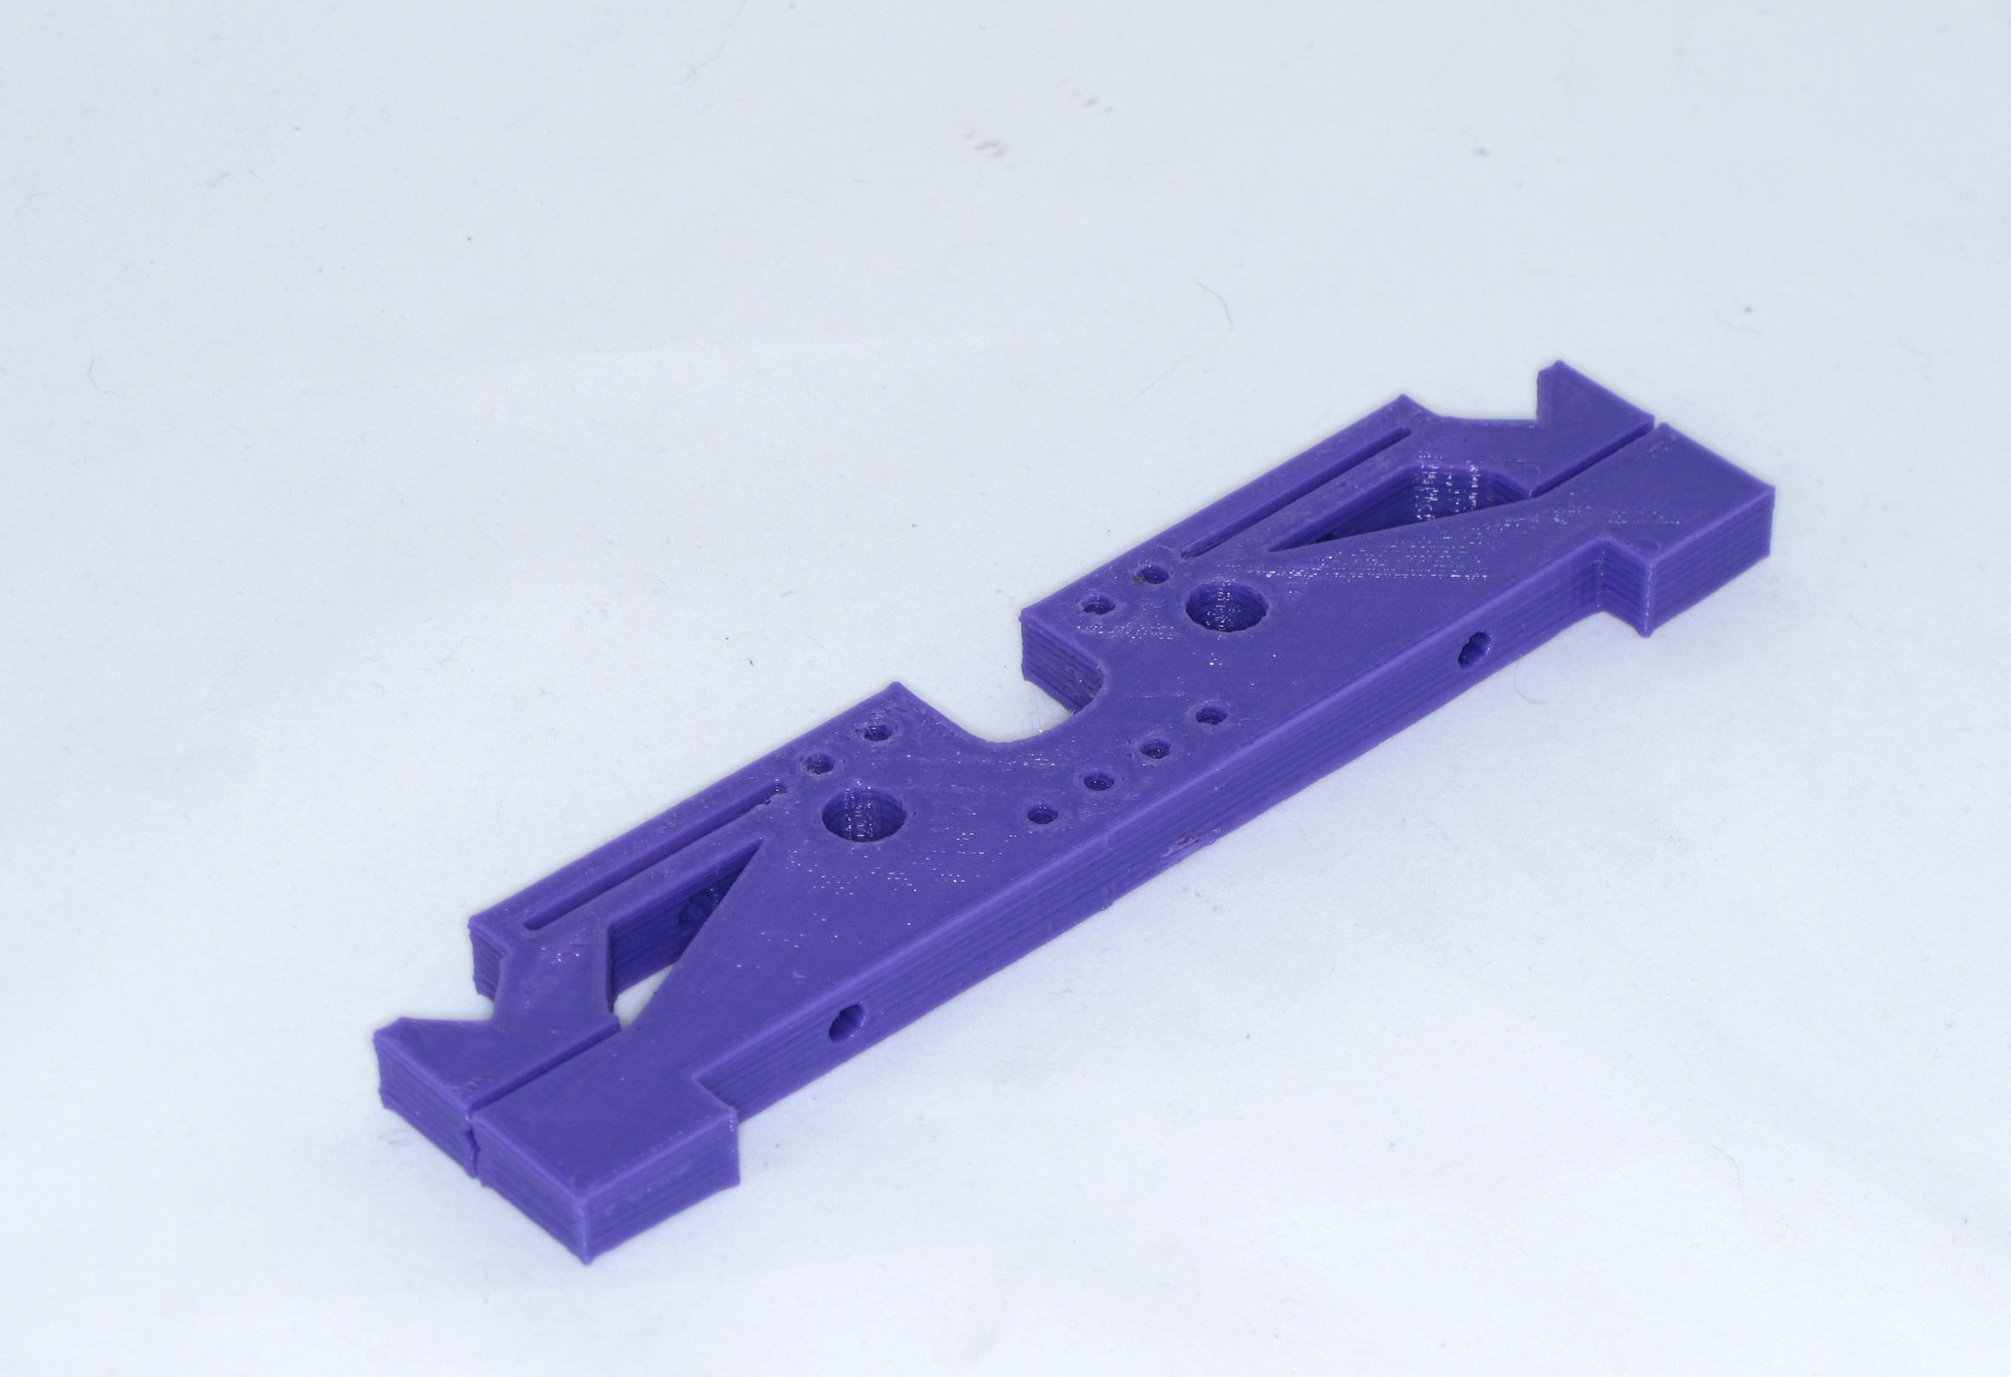Illustration 4: Y Runner x2

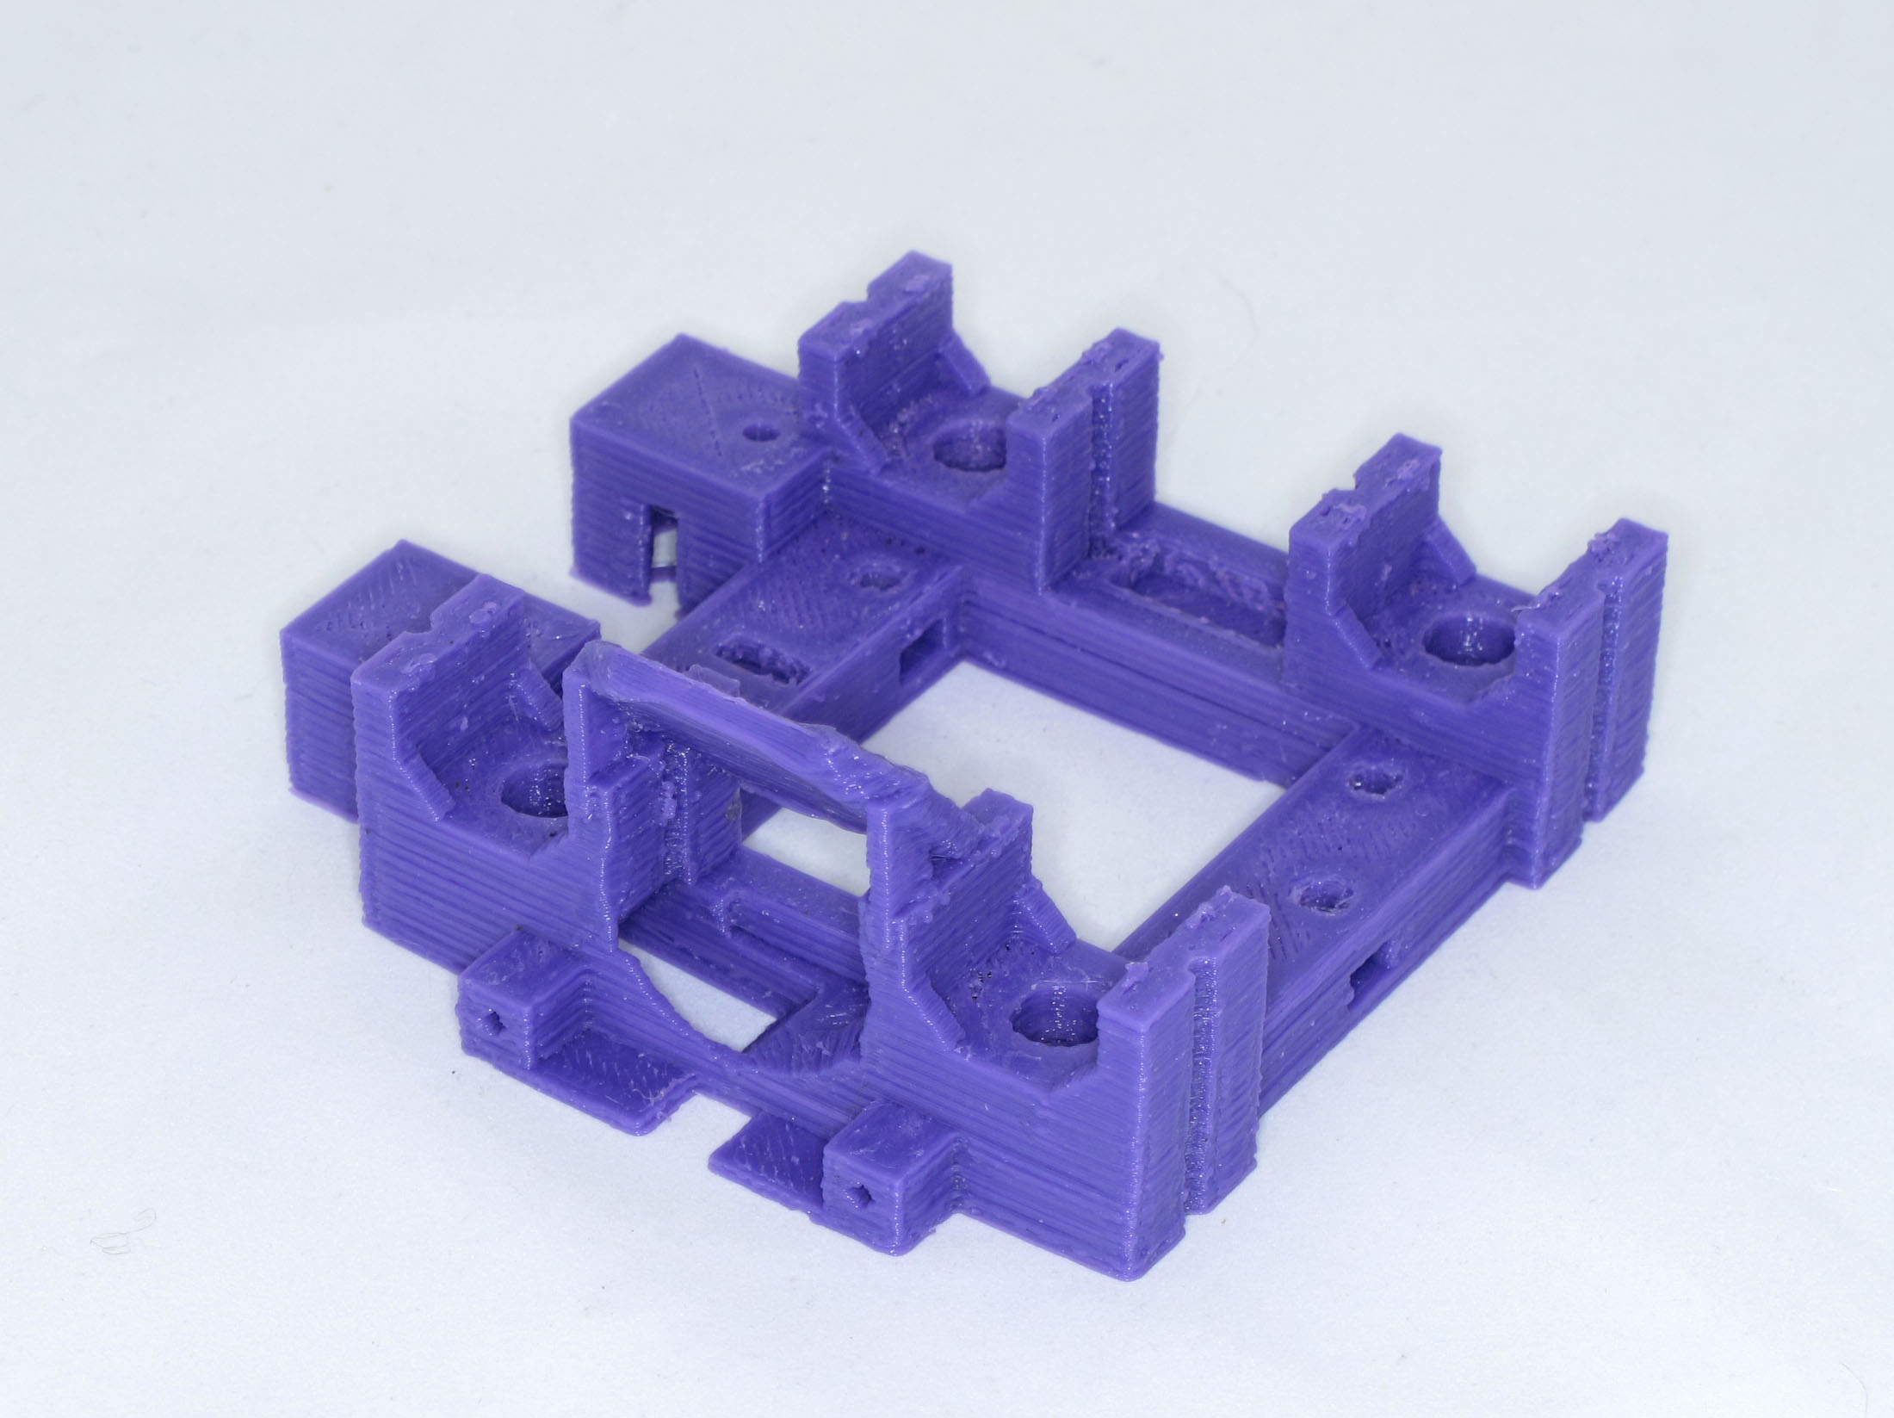Illustration 5: X Carriage
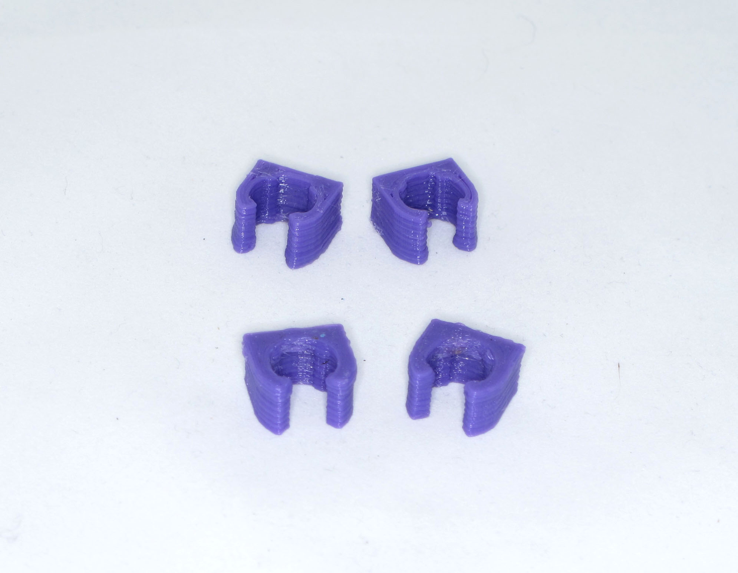Illustration 6: X Carriage Bushings

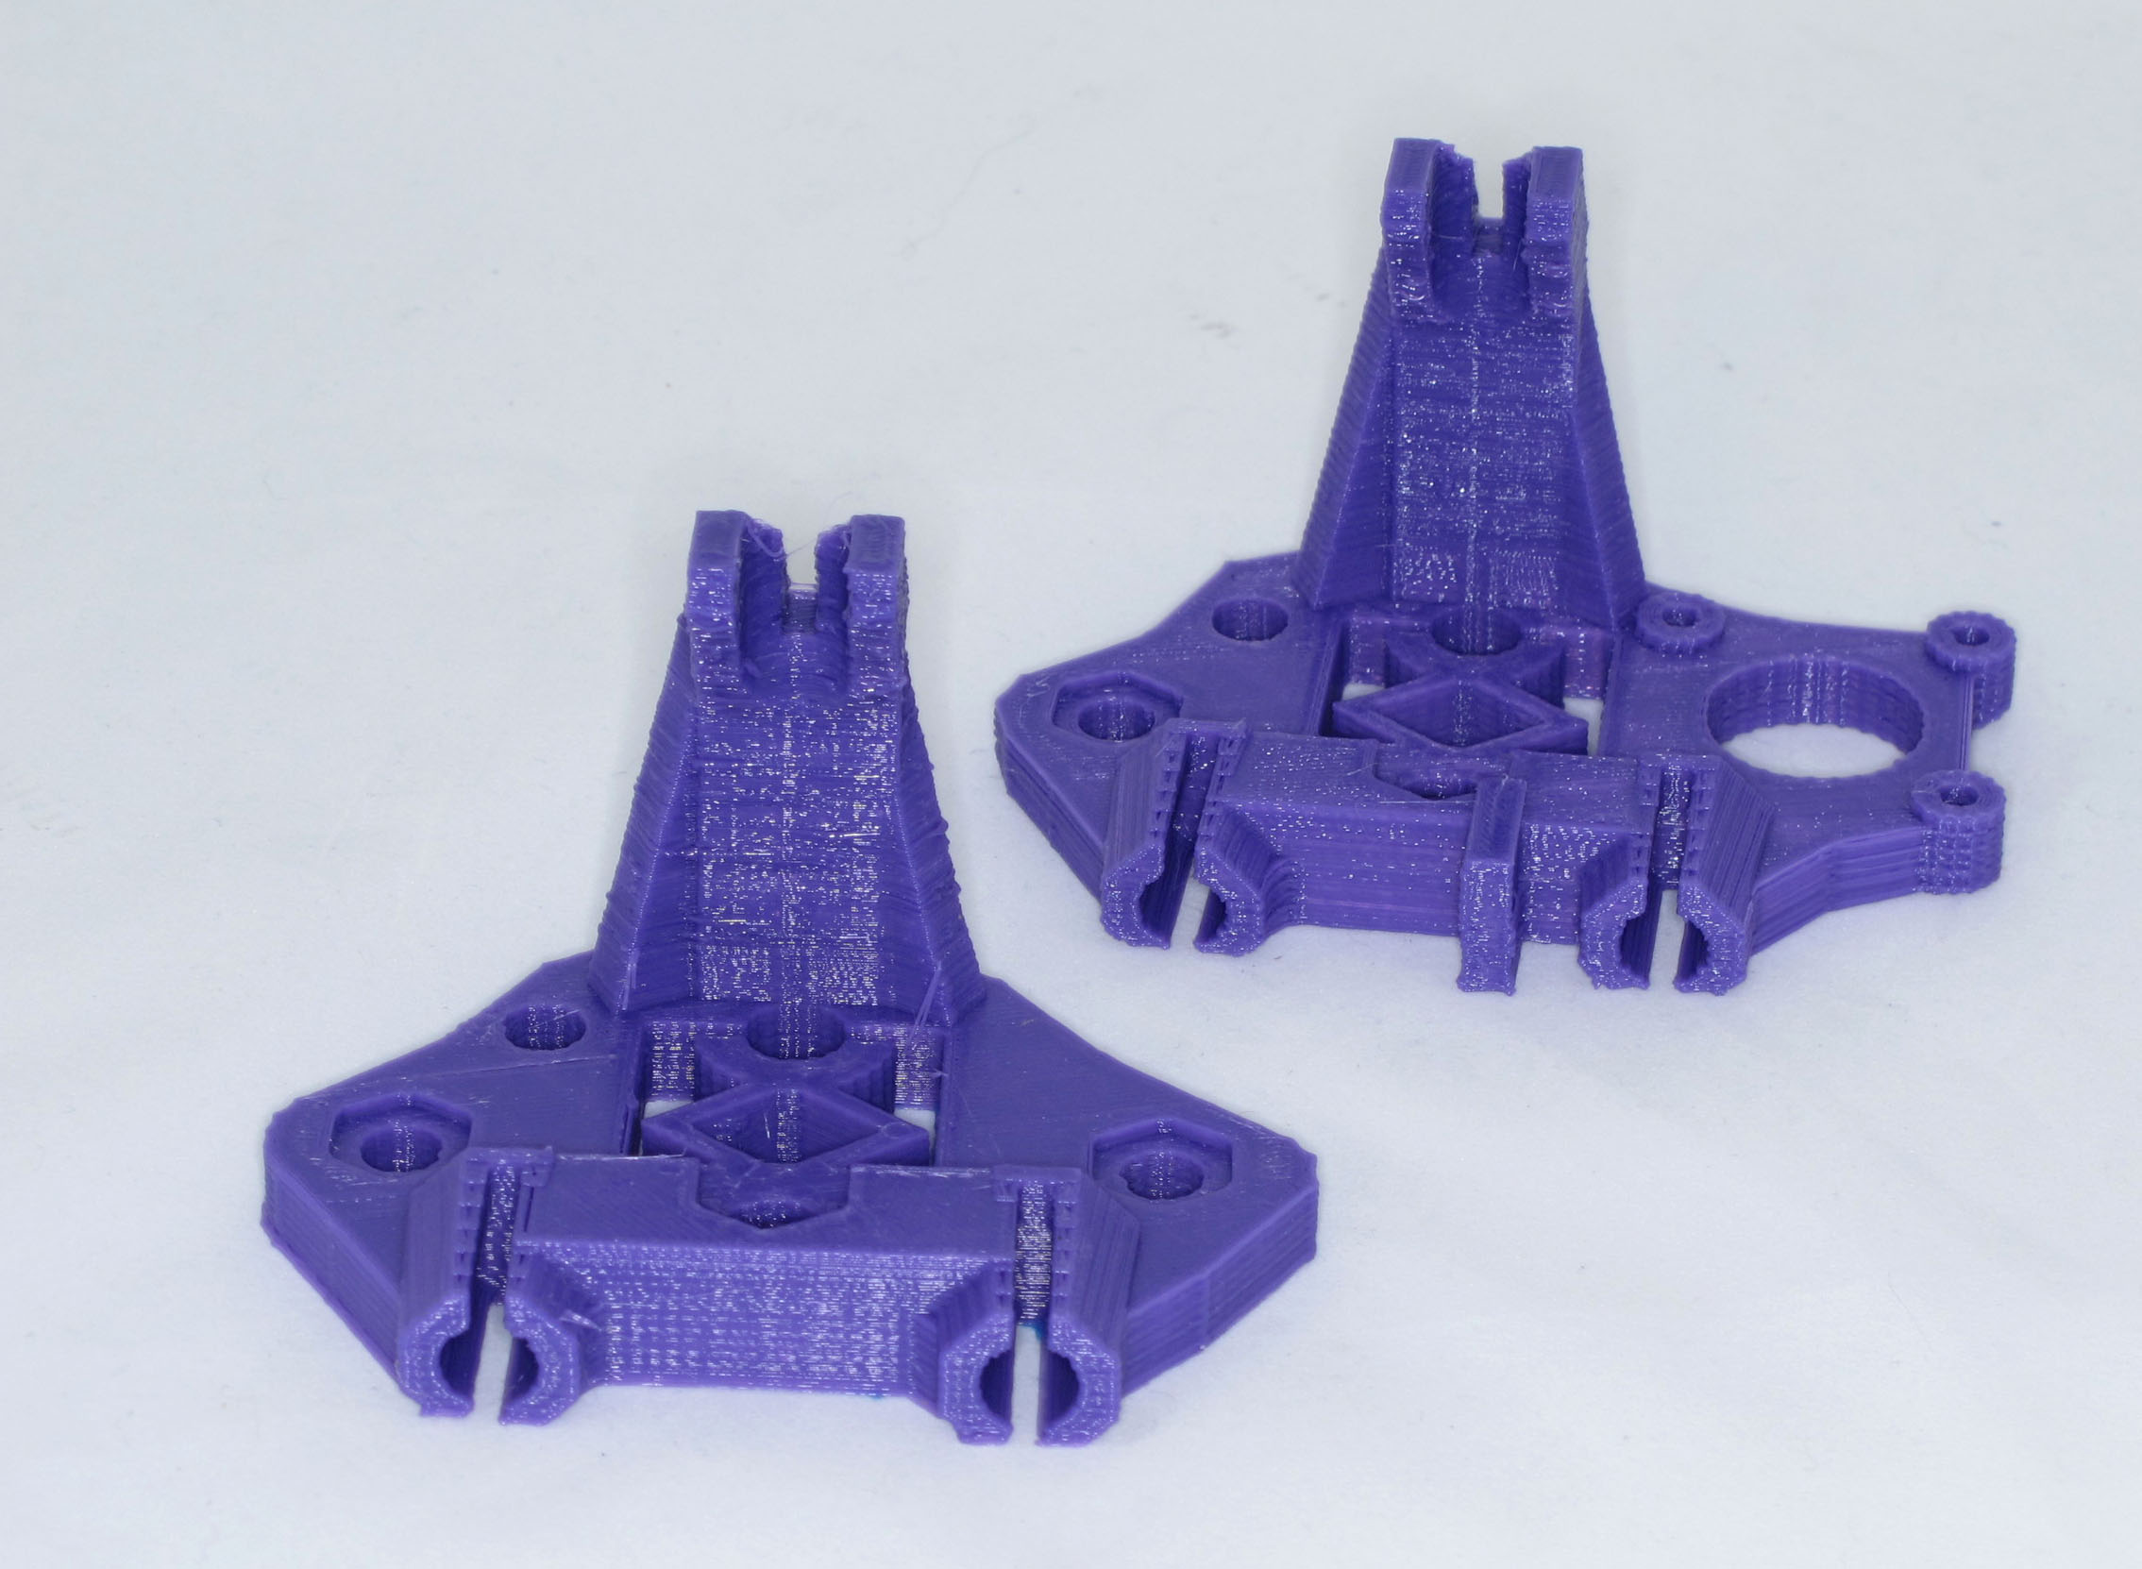Illustration 7: X Idler Bracket - X motor bracket

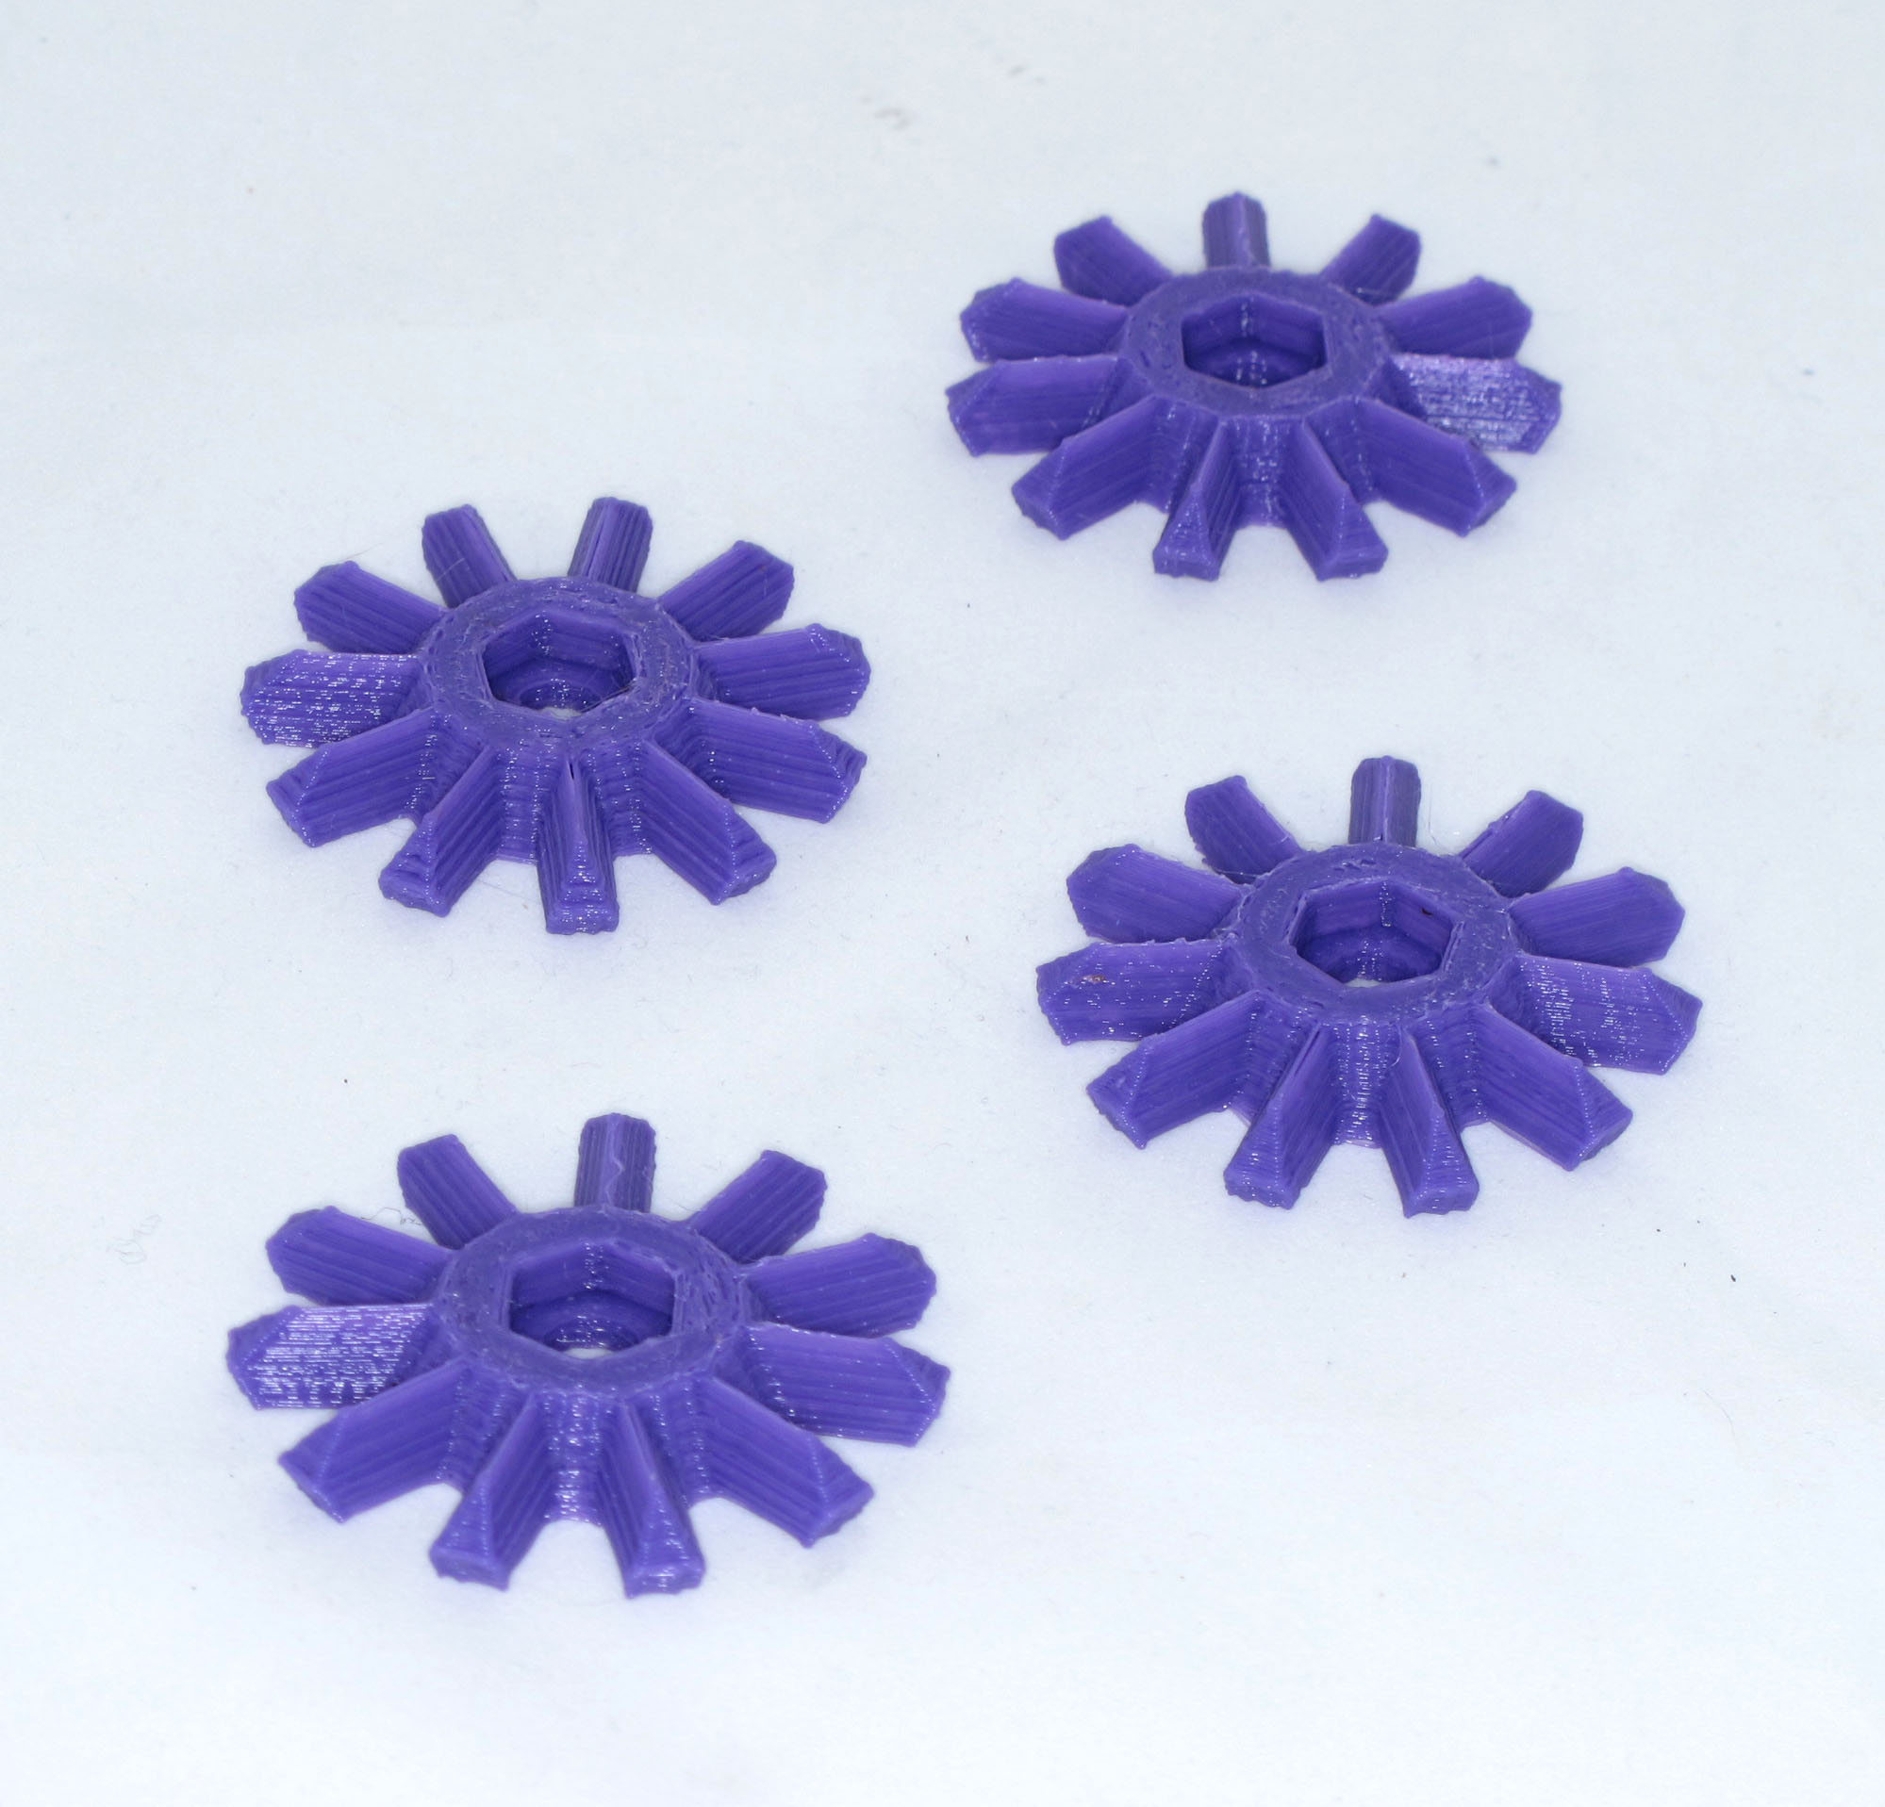Illustration 8: bevelled gears x4
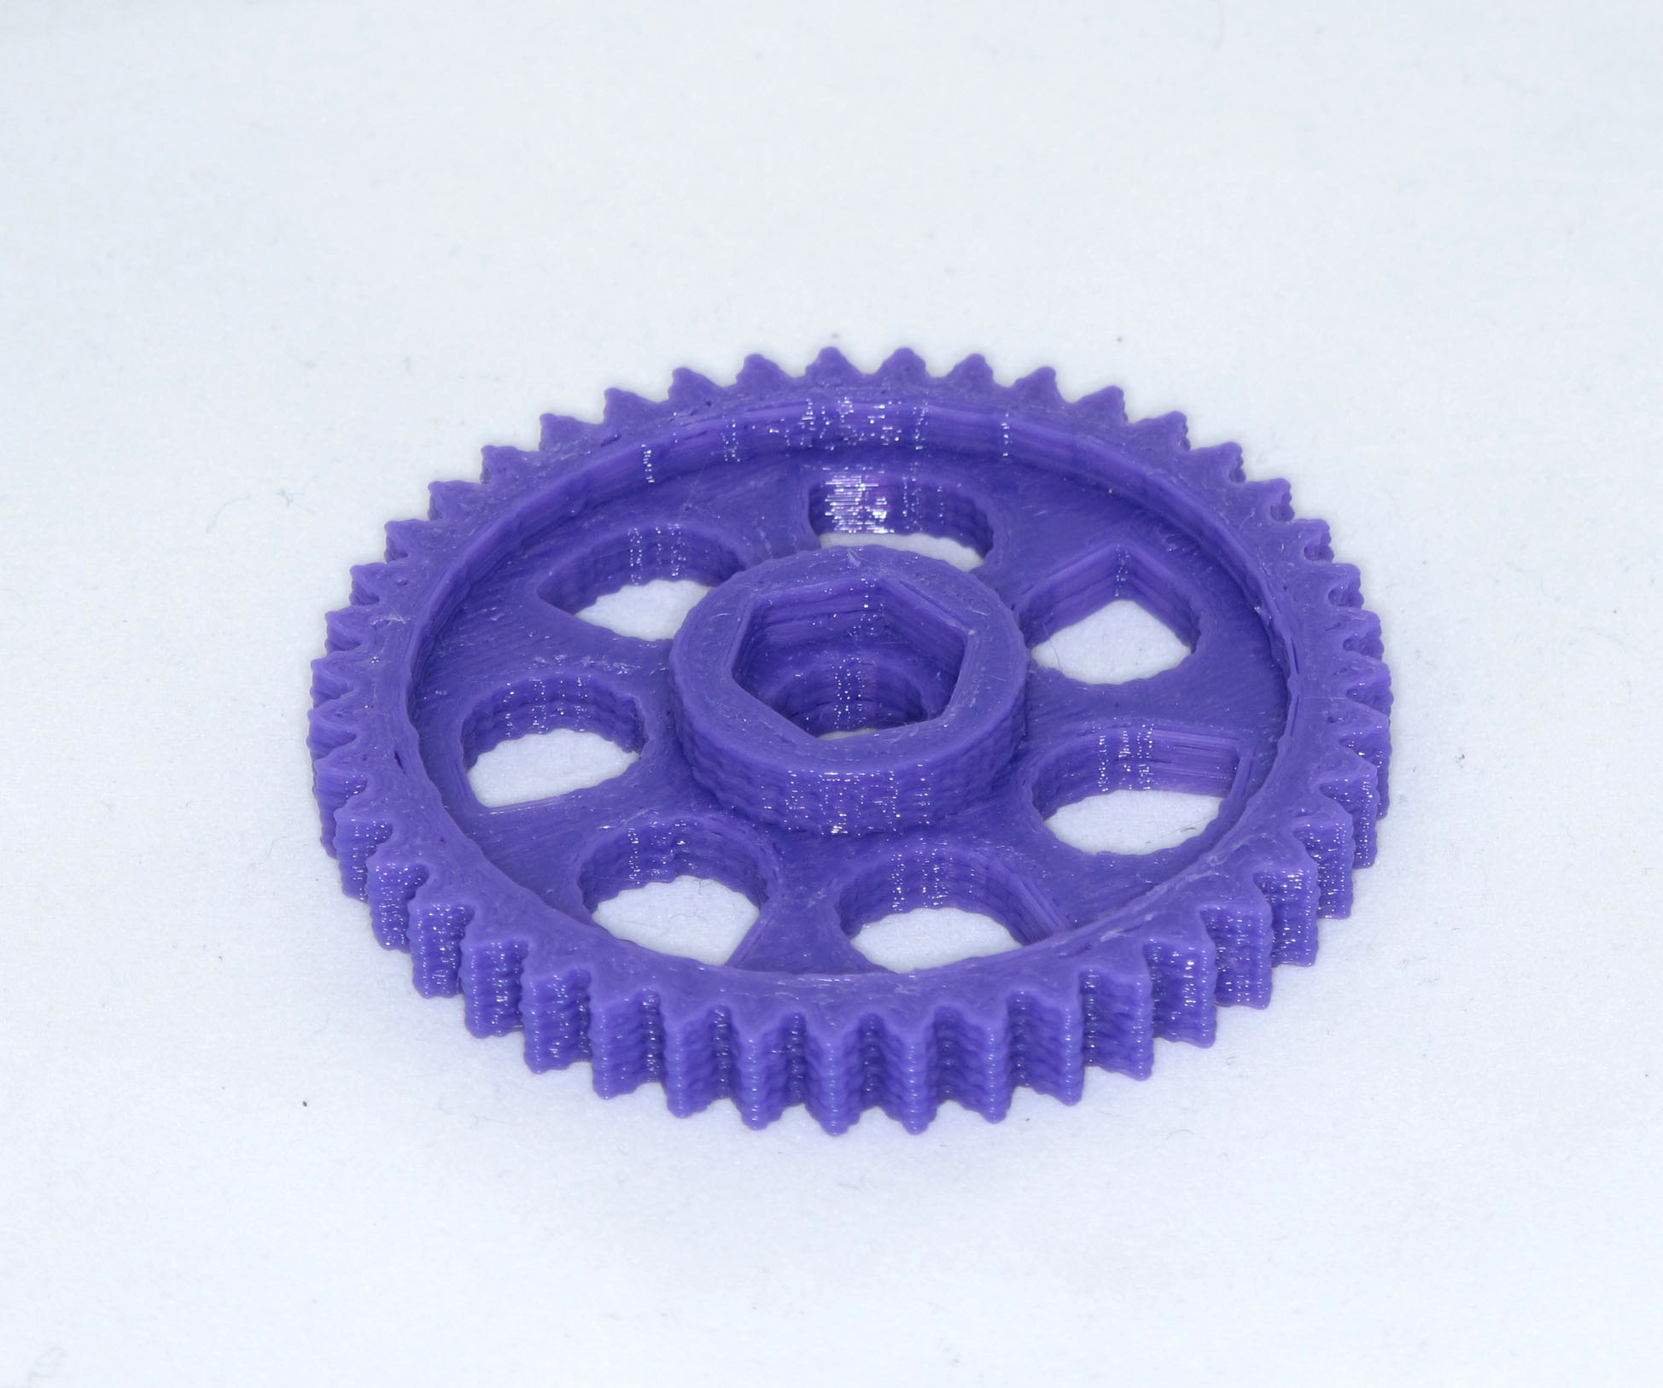Illustration 9: driven gear x2
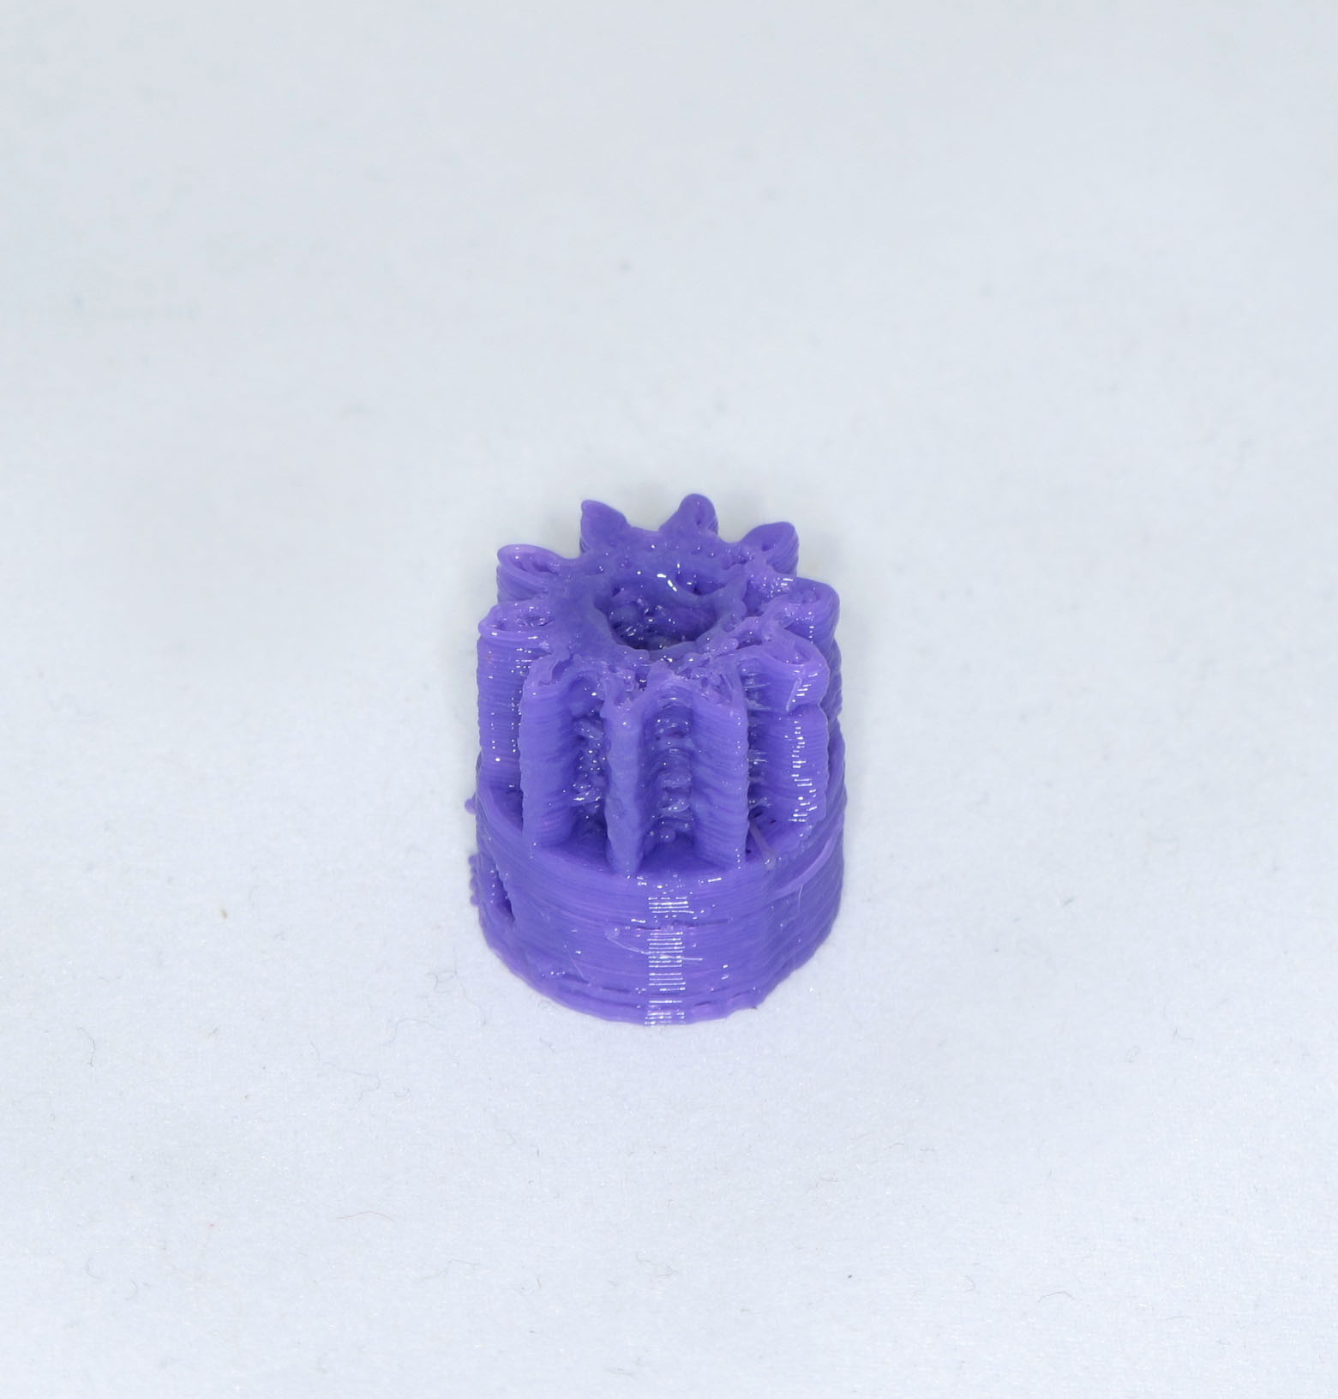Illustration 10: drive gears x3

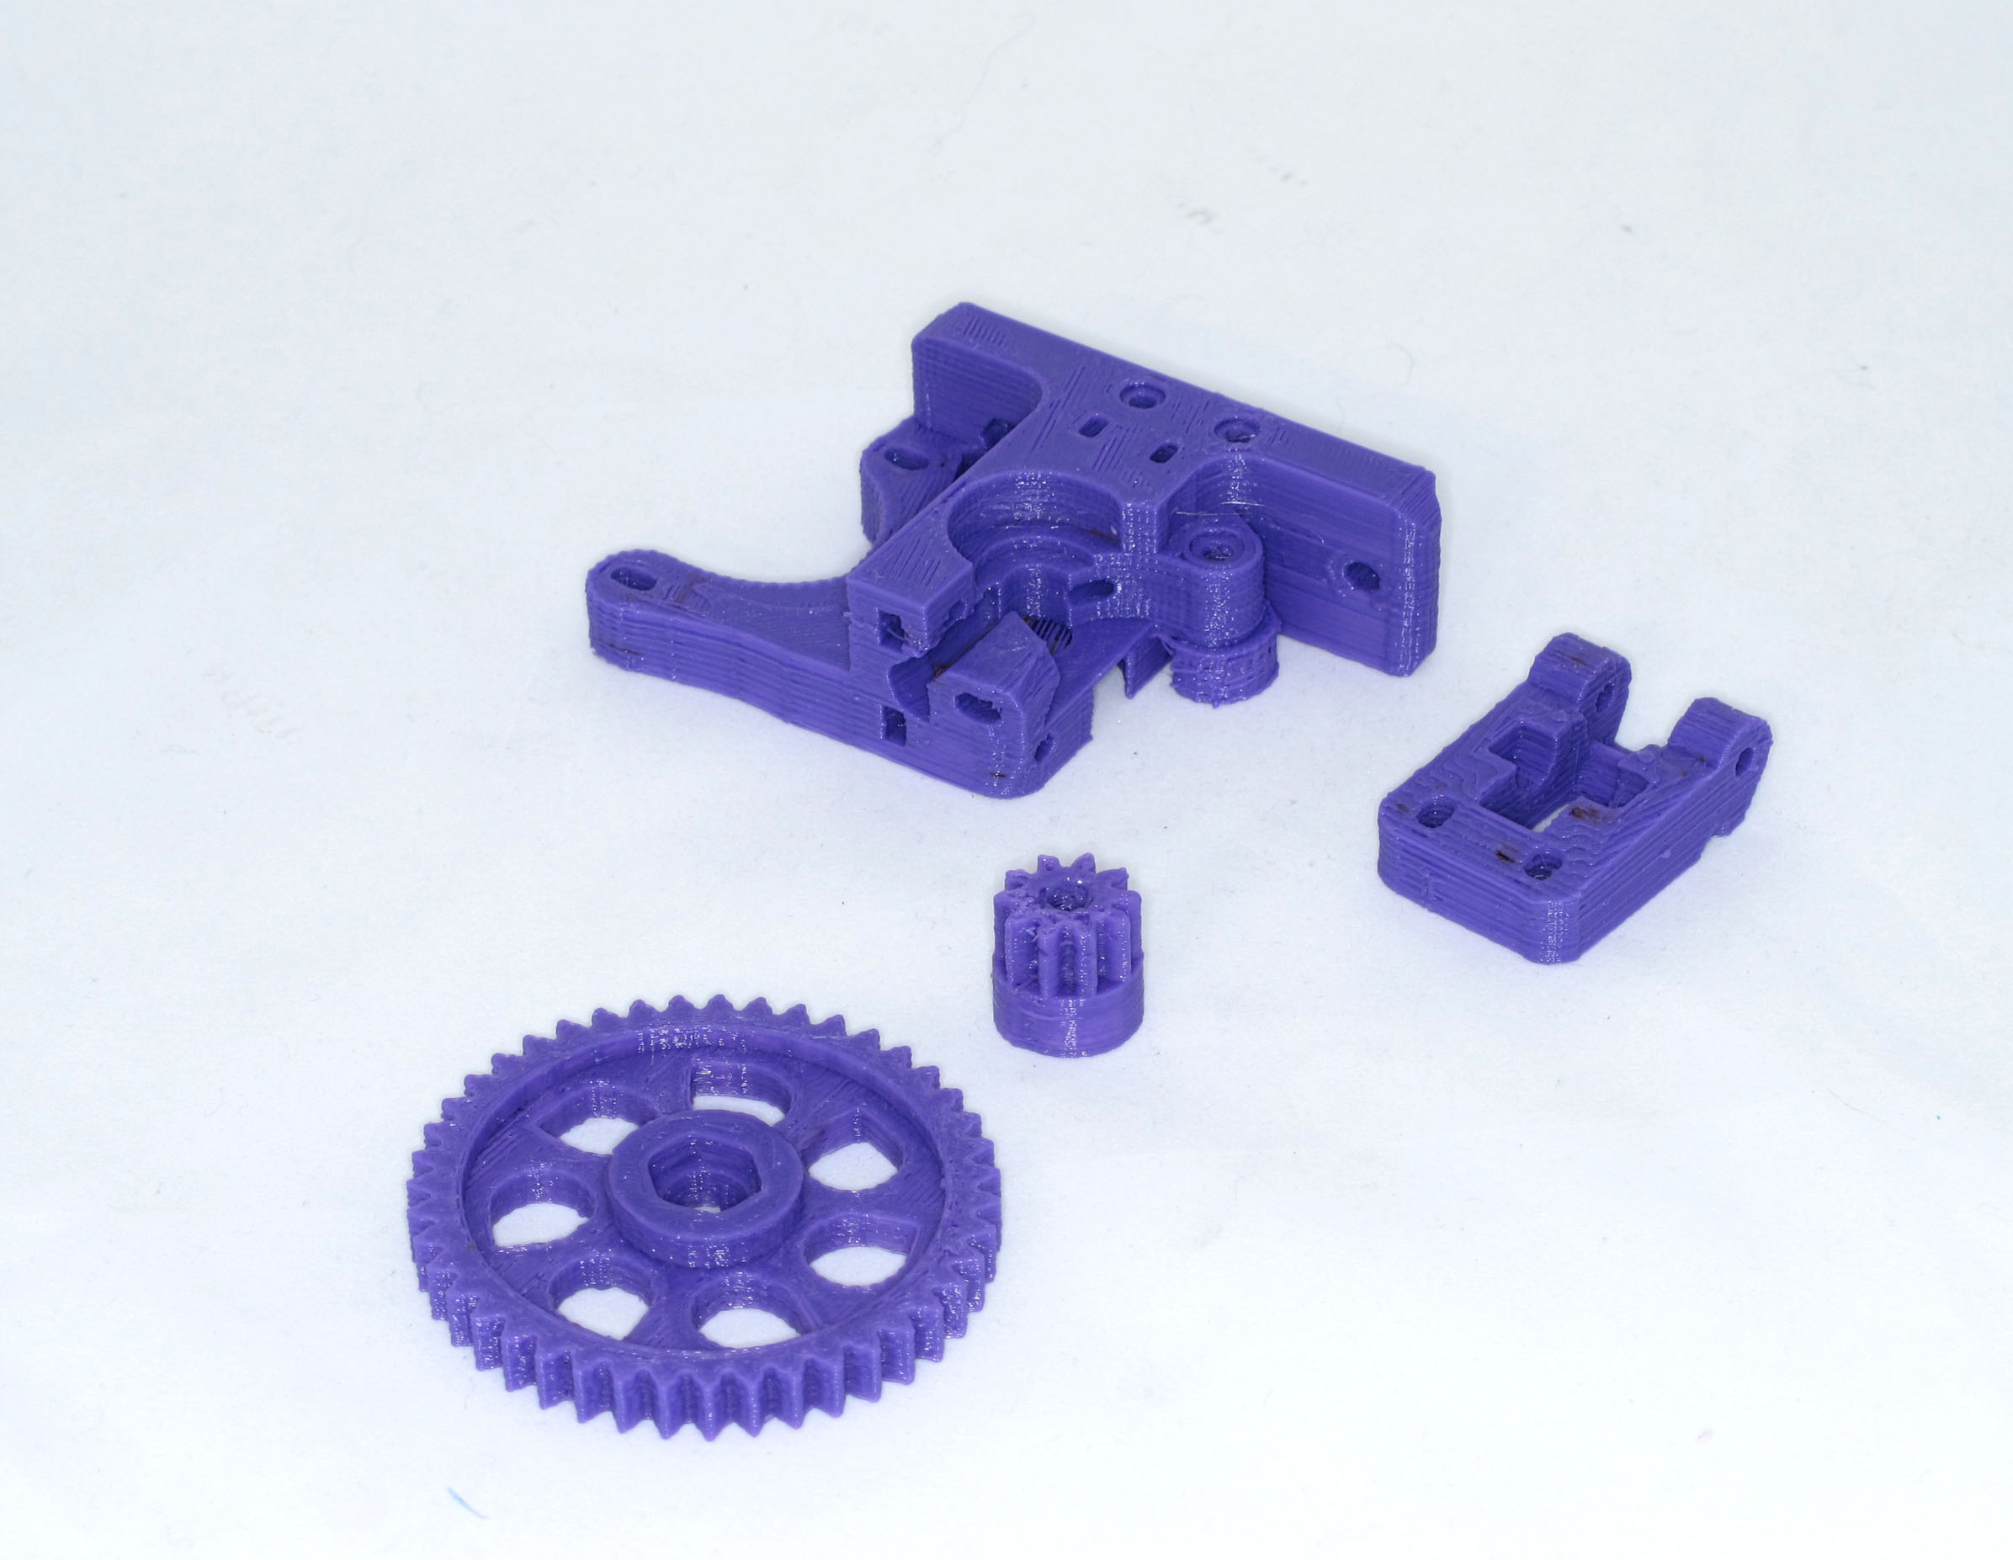Illustration 11: wade extruder components

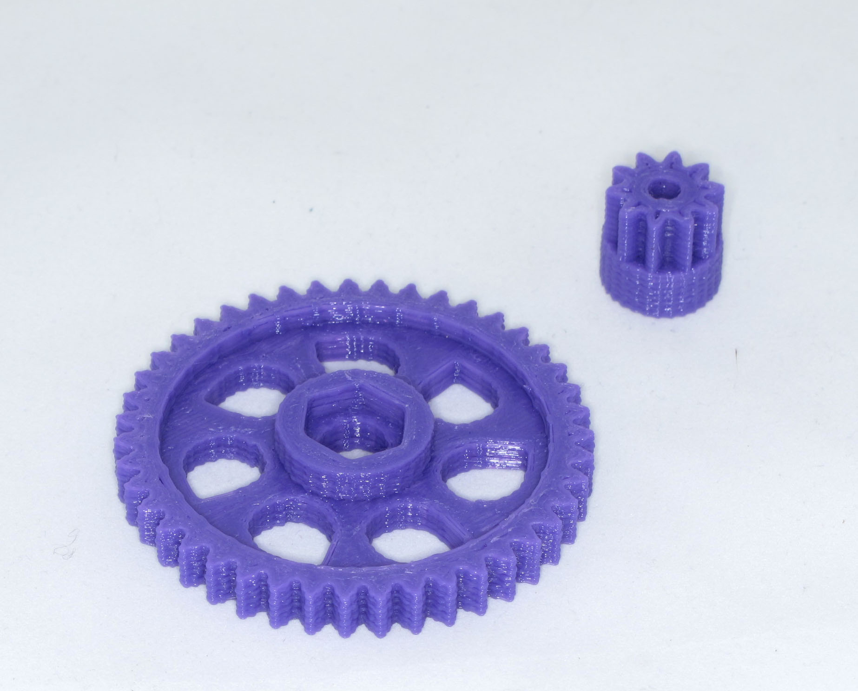Illustration 12: SPARE PIC driven gear x2 and drive gear X3

